Lab 11 - Blockchain

# Lab 11 Template

1. Part 1:
   1. **Screenshot of the genesis block**

(5 points)

* 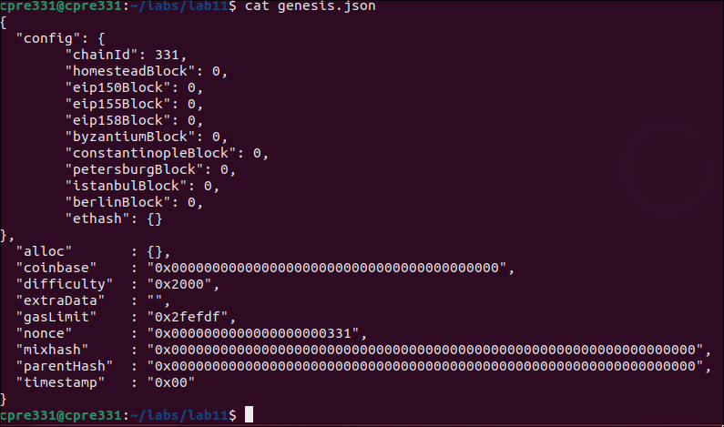

1. Part 2:
   1. **Screenshot of bootnode identifier**

(5 points)

* 
* 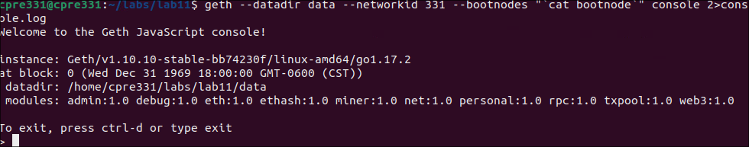
  1. **Individual node’s identifier with Ubuntu desktop’s IP address**

(15 points)

* INFO [11-11|15:43:25.925] Started P2P networking self=enode://4e8ea6b07ebabf73e109e29c7efc2a68b3895ab3f9d3ec63d3f283750c5ce3482028389c3e5fd989e686f7b3fe3eb54692012cec23f6ceb2e34d42e09a5994e4@177.110.34.1:30303
  1. **Screenshot of peer node list**

(10 points)

* 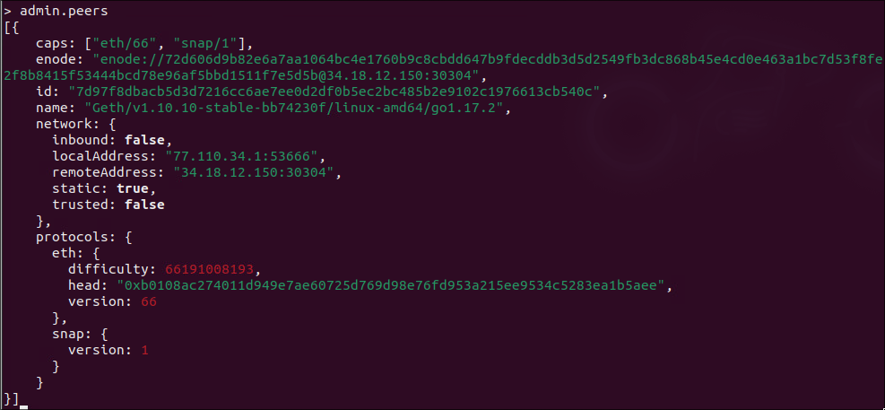

1. Part 3:
   1. **Screenshot of balance**

(5 points)

* 
  1. **Screenshot of balance two minutes later**

(5 points)

* 

1. Part 4:
   1. **Screenshot of transaction**

(10 points)

* 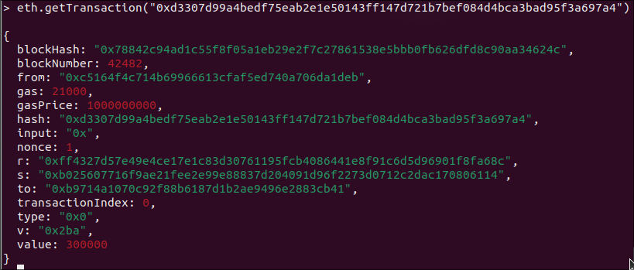
  1. **Screenshot of transaction block**

(5 points)

* 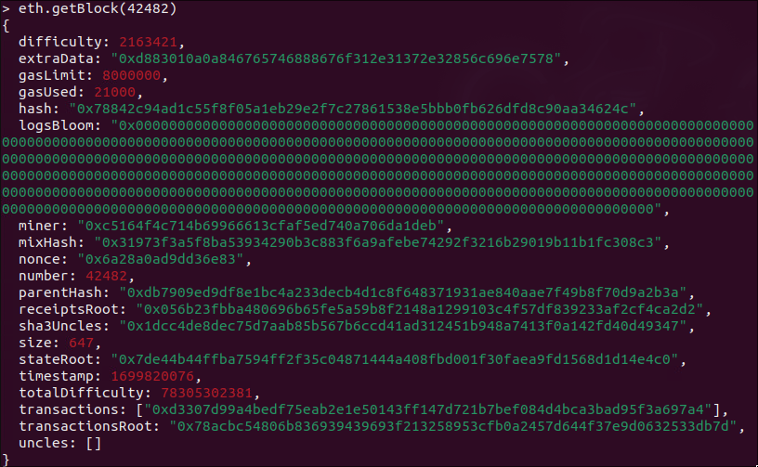
* 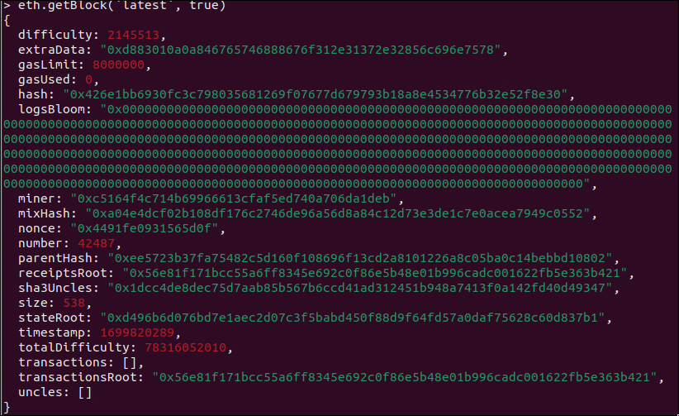
  1. **Screenshot of "final" balance after transactions**

(10 points)

* 
  1. **How many US dollars would this translate to?**

(10 points)

* 1 eth = 1.69 usd
* 54522761252801220000 usd

1. Part 5:
   1. **Screenshot of latest block number**

(10 points)

* 
  1. **Screenshot of minedBlocks output**

(10 points)

* 